**A Mini Project Report**

**On**

**“Bike Service Management System”**

**Submitted By:**

**Soham Patil**

**&**

**Rohan Bhavare**

Academic Year: 2021 – 2022



Shree Chanakya Education Society

**Indira College of Commerce and Science, Pune**

**Vice Principal & (H.O.D) Guided by:**

**Prof. Shivendu Bhushan Prof. Deven Mahajan**

**INDEX**

|  |  |  |  |
| --- | --- | --- | --- |
| **Sr.No** |  | **Particular** | **Page No.** |
| **A)** |  | **Introduction** | 4 |
|  | **1)** | Title of Project | 4 |
|  | **2)** | Existing System | 5 |
|  | **3)** | Proposed System | 6 |
|  | **4)** | Advantages of proposed System | 7 |
|  | **5)** | Feasibility Study | 8 |
|  | **6)** | Hardware/Software Requirement | 11 |
| **B)** |  | **Analysis** |  |
|  | **1)** | ERD | 12 |
|  | **2)** | DFD | 13 |
|  | **3)** | CLD | 13 |
|  | **4)** | First Level DFD | 14 |
|  | **5)** | File Design / Normalized database | 17 |
|  | **6)** | Data Dictionary | 19 |
| **C)** |  | **Design** |  |
|  | **1)** | Input screen (Without Data) | 21 |
|  | **2)** | Output screen (With Data) | 24 |
| **D)** |  | **Code Design (Sample code)** | 27 |
| **E)** |  | **Limitations of System** | 38 |
| **H)** |  | **Bibliography** | 39 |

**Acknowledgement**

We would like to express our sincere and heartfelt gratitude to our institution” Indira College of Commerce and Science” which provided us with excellent opportunity to achieve our most cherished goal in life to become bachelor’s degree in BCA(Science)

We are extremely grateful to our respected Vice Principal and HOD Prof, Shivendu Bhushan for providing excellent academic environment which has made this endeavour possible.

We take this opportunity to express our deep sense of gratitude to our guide Prof. Deven Mahajan for their resplendent idea and constant encouragement in making this project unmitigated success. Their thoughtfulness and understanding was vast and thoroughly helpful in successful completion of project. Our sincere thanks to all our faculties and non- teaching staff for their at most co-operation.

Finally, we proudly thank our parents and friends for their constant support and priceless guidance in throughout this endeavour.

Rohan bhavare & Soham Patil

**(A)**

**“Bike Service Centre Management”**

* **Introduction:**

Now a day, technology is on a boost. People wish to live a luxurious life with minimum physical work. Here we provide a web application for ‘Bike Service System’. This application is an web application which can be run on any android compatible tablets and mobile phones. The proposed app will enable any bike user to search and communicate with any bike service center in the vicinity. The user can find the service center, book bike service provided by the respective service center. The user can send request for pick and drop, appointment for servicing, test drive as well as accessories purchase to the dealer. The dealer processes these requests and gives a response back to the user through status update for invoice.

Being up-to-date with day-to-day’s documentations done on paper is hard to go through and keep proper analytical report of the ups and downs of the for the betterment of the organization is harder and time consuming as well and can cause bigger loss if the manual documentation and reports are misplaced. To overcome this problem there is a need of a proper automated system. So basically, we need to develop an automated system which will make everything quick and easier

The admin shall give access for specific modules for the other users. The users shall login and manage with the activities of the system. The supervisor shall be able to check for the inventory of vehicle spares in the garage. He shall be able to check for the vehicles that are serviced currently and the ones which has to be notified for services. The user also shall be able to note the mechanic shop time hours. The system will also allow the payment for the repair or service done. The system also can check for the vehicle spares that are sold from the garage. The interface is developed using html and PHP. It has user friendly web interface.

.

* **Existing System:**

The existing Bike Service Centre Management is all manual. The daily routines are carried out manually and the records are basically maintained in the record books or the registers. The customer makes enquiry for the booking slots available, and then depending upon the availability of the slots and their requirements they make booking. The data that receptionist used to give to the customer is based on paper works, there is no actual idea of the status of rooms as there is no regular updating of the status. The clerk operates the bill department to generate the bill of the customer as per the services utilized by the customers. The administrator views all the reports which are written manually, he goes through the reports of various departments, customer’s interest type to check the progress of the Service centre and to make the necessary changes.

* **Disadvantage of Existing System:**

1. In the Existing system, due to the hectic paper work to be maintained for every task, the hotel has to employer more employees and pay them according to their work every month which increases the maintaining cost of the paper work as well as the manpower as it would be time consuming and hard for a single person to do all the work alone.
2. The customer has to roam different service centers in the search of available services as per their requirements.
3. Due to the lack of communication among the workers themselves the same task might happen several times which might create confusion among the workers and disappointment for the customers in the sense of the service given.
4. The manual work system is prone to insecurities.
5. As its all paperwork sometimes the guidelines might get disrespected and few services can be given to the one who is not eligible for it

6. Customer can’t see Job card details after servicing of bike.

* **Proposed System:**

The main objective of the proposed system is to remove all the disadvantages of the conventional system and to develop an automated Bike Service Center Management System

The purpose of this project is to provide Bike or any other automobile servicing system more effectively than the existing system. There are some disadvantages of the existing service center management systems. These disadvantages are overcome by the bike service center management system. And it can be made handily available to every person. Previously people could not get help or locate the service centers conveniently in case of their car break-down or any other emergencies. Thus BSCM is proposed to assist people and fulfill their requirements easily

Easy to use because all Details of bike sales & servicing will quickly available 24 x 7 on website.

It can be easily accessed globally with help of Internet.

Maintaining records will be easier because all details are stored in database and retrieved easily from it.

Interactive and attractive design.

Provides Alerts or Reminder by E-MAIL.

Provides online booking of bike and servicing easily

.

So, with this realization our project Bike Service Center Management System comes into consideration and befit the organization as a whole.

* **Advantages of Proposed System:**

1. Efficient, fast, reliable and user-friendly system.
2. Admin can get the daily accurate report of the day to day activities.
3. As the website is going to be available online, more people will know about the service center and which will lead to increase in number bookings.
4. The customer will not have to roam , instead they can get services according to their requirements choice in just few clicks.
5. This means a better customer experience and more time for staff to focus on their important work, and more reliable business data and reporting.

* **Drawbacks of Proposed System:**

1. The booking will require device and internet. Customer might not have proper internet connection or might not be familiar with the workings.
2. If one staff mistypes the information than the guest might get angry.
3. If there is a power failure, while making a reservation than the staff must redo the whole reservation.

1

* **Feasibility study:**
* Economical Feasibility:

As a part of this, the costs and benefits associated with the proposed system are compared and the project is economically feasible only if tangible and intangible benefits outweigh the cost. The cost for proposed hotel management system is outweighing the cost and efforts involved in maintaining the registers, books, files and generation of various reports. The system also reduces the administrative and technical stuffs do various jobs that single software can do. So, this system is economically feasible.

* Legal Feasibility:

Legal feasibility determines whether the proposed system conflicts with legal requirements, e.g. The Data Protection Act. It will be done by some legal advisor.

* Technical Feasibility:

In this, one has to test whether the system can be developed using existing technology or not. We have used VS Code as front-end and Microsoft Access as backend. We use operating system as ‘Microsoft Windows’ which can be available all the time. It is evident that necessary hardware and software are available for development and implementation of proposed system. We have hardware like LCD monitor, normal keyboard and compatible mouse which are available on every pc.

* Behavioral Feasibility:

It evaluates and estimates the user attitude or behavior towards the development of new system.

It helps in determining if the system requires special effort to educate, retrain, transfer, and changes in employee’s job status on new ways of conducting business.

.

* **Function Specification:**
* Admin:
* Login
* Worker details
* Customer details
* Payment information
* Customer:
* Login/signup
* Booking details
* Bike details
* Payment

|  |  |
| --- | --- |
| **Software Requirement** | |
| Operating System | Microsoft windows |
| **Software :-** | |
| Front –End Software | VS Code (HTML, CSS) |
| Back-End Software | Microsoft Access (Oracle) |
| **Hardware Requirement** | |
| Processer : | Intel core i3 1.80GHZ |
| RAM : | 2GB or More |
| Monitor : | LCD monitor |
| Keyboard : | Normal keyboard |
| Mouse : | Compatible mouse |

* **Software and Hardware Requirements:**

### (B) “Analysis”

* **Entity Relationship Diagram:**

**BIKE SERVICE SYSTEM**

**Data flow diagram:**

**PAYMENT**

**Accept**

**LOGIN**

**HAS**

**HAS**

**USER**

**SERVICE CENTER**

**BOOKING**

**Manages**

* **Context Level Diagram:**

0.0

Bike Service Center

MANAGEMENT

SYSTEM

Admin details

Admin

salary

Query 

Admin

report

salary

Customer details

Worker

Worker

Booking

Booking

Worker details

Customer

Customer details

Customer

Payment details

* **First Level Diagram:**

1.0

employee details

employee

Booking details

employee

MASTER

GENERATION

PROCESS

payment details

Payment

employee details

Bike details

Booking

booking

Payment details

2.0

username

login

password

username

Admin

password

Access

LOGIN

PROCESS

validate

ENQUIRY PROCESS

3.0

Booking details

Worker

customer details

Booking details

update

Customer details

Bike

Customer

update customer

Customer details

information

Payment details

Customer



4.0

Worker details

Worker

Booking details

Customer details

Worker

payment

Booking details

Customer payment

Payment details

Payment

Customer

Invoice

5.0

REPORT GENERATION PROCESS

Booking details

Booking

Payment details

query

Admin

Payment

report

Worker details

Worker

Customer details

Customer

**File design/ Normalized database:**

Table name: Worker

|  |  |  |  |  |
| --- | --- | --- | --- | --- |
| Sr.no | Fields name | Data type | Width | Constraints |
| 1. | W_id | Number | 8 | Primary key |
| 2 | W_name | Short text | 20 | Not Null |
| 3 | W_addr | Short text | 30 | Not Null |
| 4 | W_phno | Number | 10 | Not Null |

Table name: Customer

|  |  |  |  |  |
| --- | --- | --- | --- | --- |
| Sr.no | Fields name | Data type | Width | Constraints |
| 1 | C_id | Number | 8 | Primary key |
| 2 | Ad_id | Number | 8 | Foreign key |
| 3 | C_name | Short text | 20 | Not Null |
| 4 | C_addr | Short text | 30 | Not Null |
| 5 | C_phno | Number | 10 | Not Null |

Table name: Admin

|  |  |  |  |  |
| --- | --- | --- | --- | --- |
| Sr.no | Fields name | Data type | Width | Constraints |
| 1 | Ad_id | Number | 8 | Primary key |
| 2 | Ad _name | Short text | 20 | Not null |
| 3 | Ad _phno | Number | 10 | Not Null |

Table name: Booking

|  |  |  |  |  |
| --- | --- | --- | --- | --- |
| Sr.no | Fields name | Data type | Width | Constraints |
| 1 | Booking_id | Number | 8 | Primary key |
| 2 | Booking_Biketype | Short text | 15 | Not null |
| 3 | Login_id | Number | 8 | Foreign Key |

Table name: Login

|  |  |  |  |  |
| --- | --- | --- | --- | --- |
| Sr.no | Fields name | Data type | Width | Constraints |
| 1 | Login_id | Number | 8 | Primary key |
| 2 | Login_password | Short text | 10 | Not null |

Table name: Payment

|  |  |  |  |  |
| --- | --- | --- | --- | --- |
| Sr.no | Fields name | Data type | Width | Constraints |
| 1 | Pay_id | Number | 11 | Primary key |
| 2 | Pay_date | Date | 10 | Not null |
| 3 | Pay_type | Short text | 10 | Not null |
| 4 | C_id | Number | 8 | Foreign Key |

**Data Dictionary:**

|  |  |  |  |  |  |  |
| --- | --- | --- | --- | --- | --- | --- |
| Sr.  No | Field name | Data type | Width | constraints | Table name | Data description |
| 1 | W_id | Number | 8 | Primary key | Worker | Worker id |
| 2 | W_name | Short text | 20 | Not Null | Worker | Worker Name |
| 3 | W_addr | Short text | 30 | Not Null | Worker | Worker Address |
| 4 | W_phno | Number | 10 | Unique | Worker | Phone number |
| 5 | C_id | Number | 8 | Primary key | Customer | Customer id |
| 6 | C_name | Short text | 20 | Not Null | Customer | Customer name |
| 7 | Ad _id | Number | 8 | Foreign Key | Customer | Admin Id |
| 8 | C_addr | Short text | 30 | Not Null | Customer | Customer address |
| 9 | C_phno | Number | 10 | Unique | Customer | Customer phoneno |
| 10 | Ad _id | Number | 8 | Primary key | Admin | Admin id |
| 11 | Ad_name | Short text | 20 | Not null | Admin | Admin name |
| 12 | Ad_phno | Number | 10 | Unique | Admin | Admin phoneno |
| 13 | Booking_id | Number | 8 | Primary key | Booking | Booking id |
| 14 | Login_id | Number | 8 | Foreign Key | Booking | Login Id |
| 15 | Booking_type | Short text | 15 | Not null | Booking | Booking type |
| 16 | Login_id | Number | 8 | Primary key | Login | Login id |
| 17 | Login_pass | Short text | 10 | Not null | Login | Login password |
| 18 | Pay_id | Number | 11 | Primary key | Payment | Payment id |
| 19 | C_id | Number | 8 | Foreign key | Payment | Customer id |
| 20 | Pay_date | Date | 10 | Not null | Payment | Payment date |
| 21 | Pay_type | Short text | 10 | Not null | Payment | Payment type |

**(C)**

**“Design”**

**Home Page**

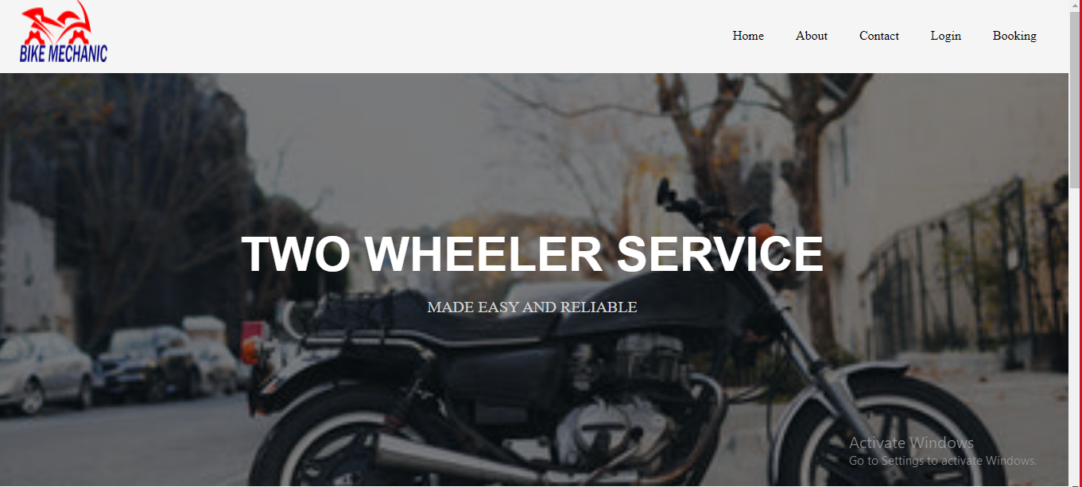

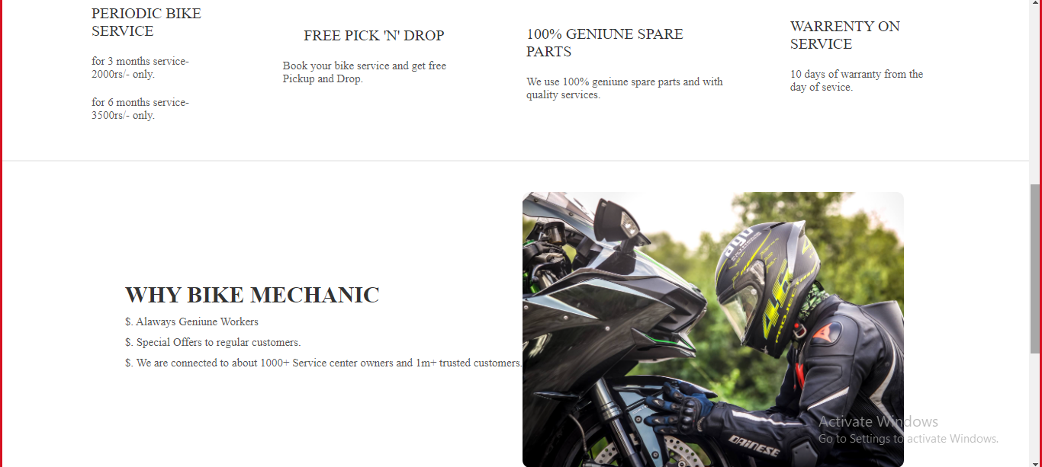

**About Us**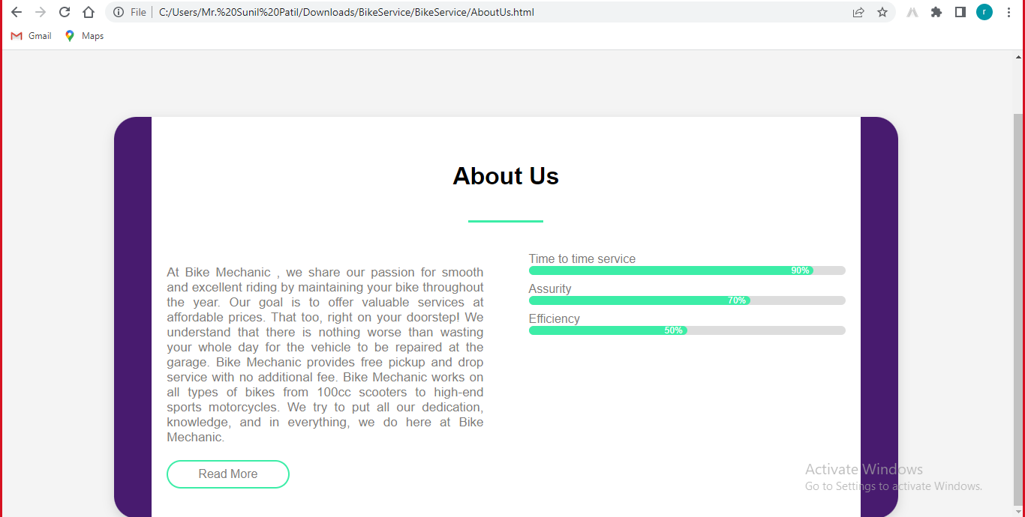

**Contact us**

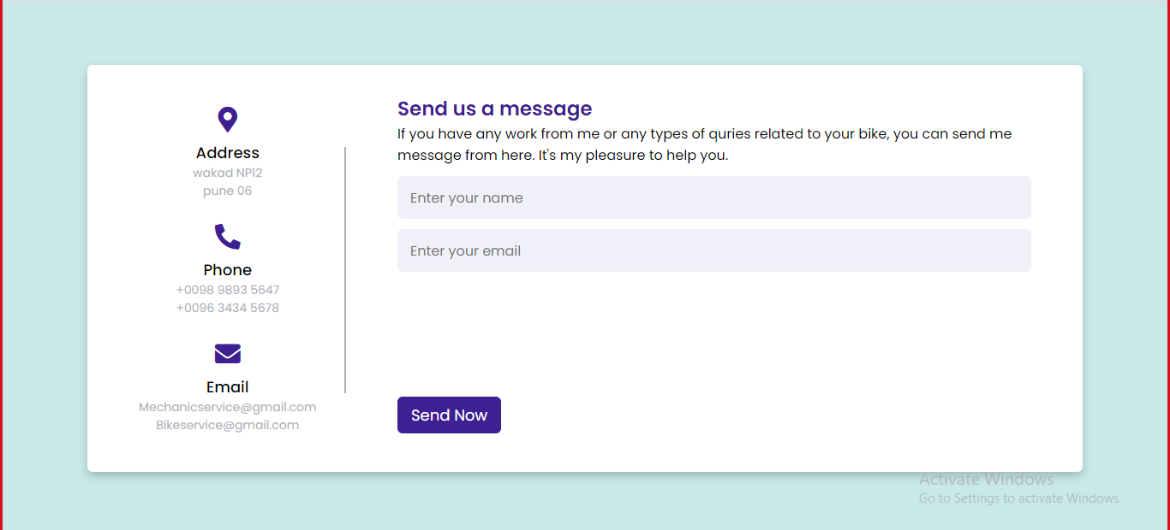

**Admin Login Page**

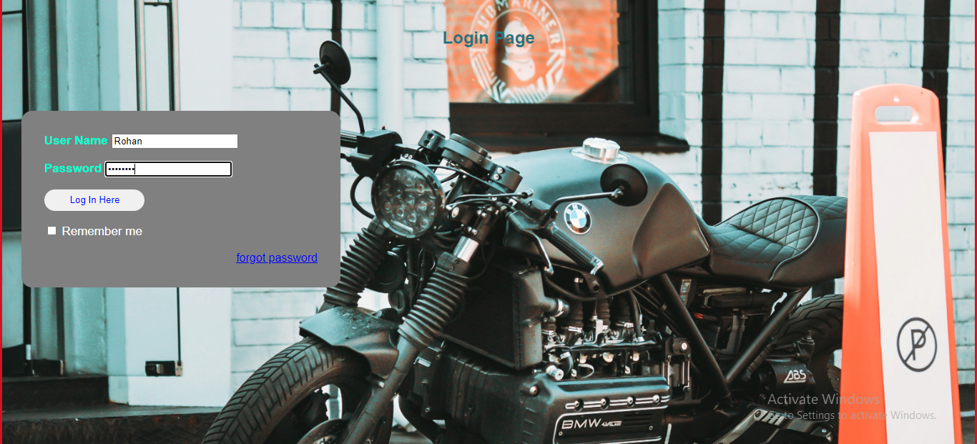

**Log-in After Booking Page**

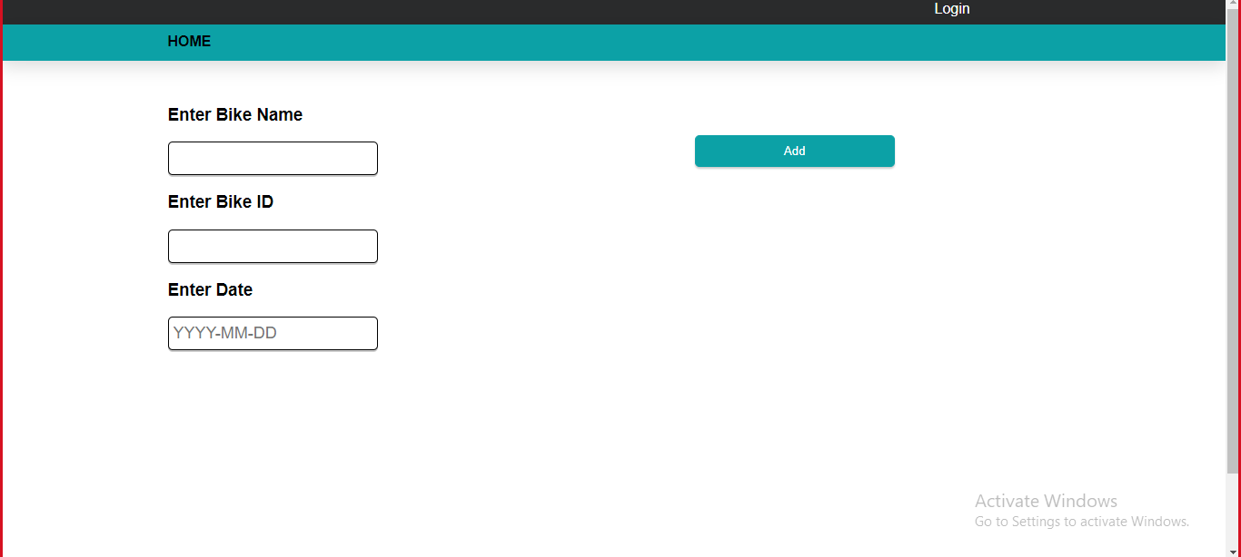

**(D)**

**Limitations:**

1. As everything is software based now it is unable to analyze past data.
2. Storage problem.
3. The software needs to be renewed each year.

**(F)**

**Future Enhancement :**

This system is found tested and examined for its successful processing. Future change in the

environment or processing can be easily adopted by having simple change in coding. It is very

user friendly, cost effective, feature rich and it provides very high level of security. It protects

from the unauthorized users. Moreover, the system coding is so well designed that new

operations can be easily incorporated without much modifications. A facility to inform the

complainant through SMS or Email on landing of the consignment can be added in future.

**(E)**

**Bibliography:**

* **Book references:**

1. Tim Crosby (2007), How inventory Management System Work Retrieved 22, June 2013
2. Software Engineering A Practitioners Approach 8th Edition.
3. Martin Grouber By BBB Publications.

* **Web References:**

1. <https://www.javatpoint.com/software-engineering-tutorial>
2. <https://www.w3schools.com/>
3. <https://www.tutorialspoint.com/software_engineering/index.htm>